FOCP C Programming Assignment
Module 3: Loops
Question 6: Number Line Jumps (Kangaroo)
Platform: HackerRank
Programming Language: C
Problem Link: https://www.hackerrank.com/challenges/kangaroo/problem
Problem Statement
Two kangaroos are standing on a number line and moving in the positive direction.
- The first kangaroo starts at position x1 and jumps v1 meters each time.
- The second kangaroo starts at position x2 and jumps v2 meters each time.
Determine whether both kangaroos can reach the same position after the same number of jumps.
If they meet, return YES. Otherwise, return NO.
Input Format
A single line containing four space-separated integers: x1, v1, x2, and v2.
Sample Input 0
0 3 4 2
Sample Output 0
YES
Sample Input 1
0 2 5 3
Sample Output 1
NO
Source Code
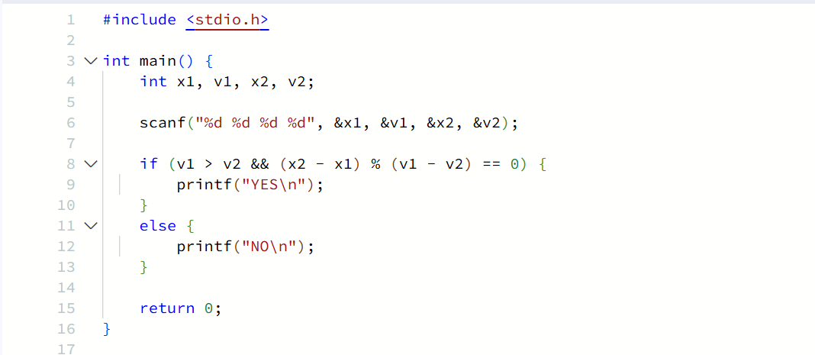Output
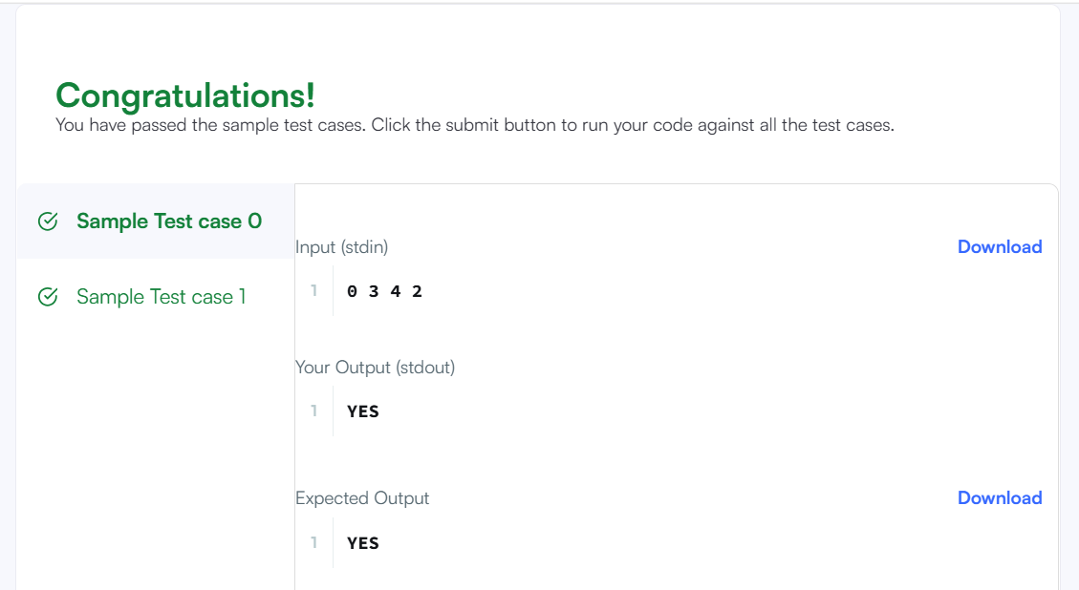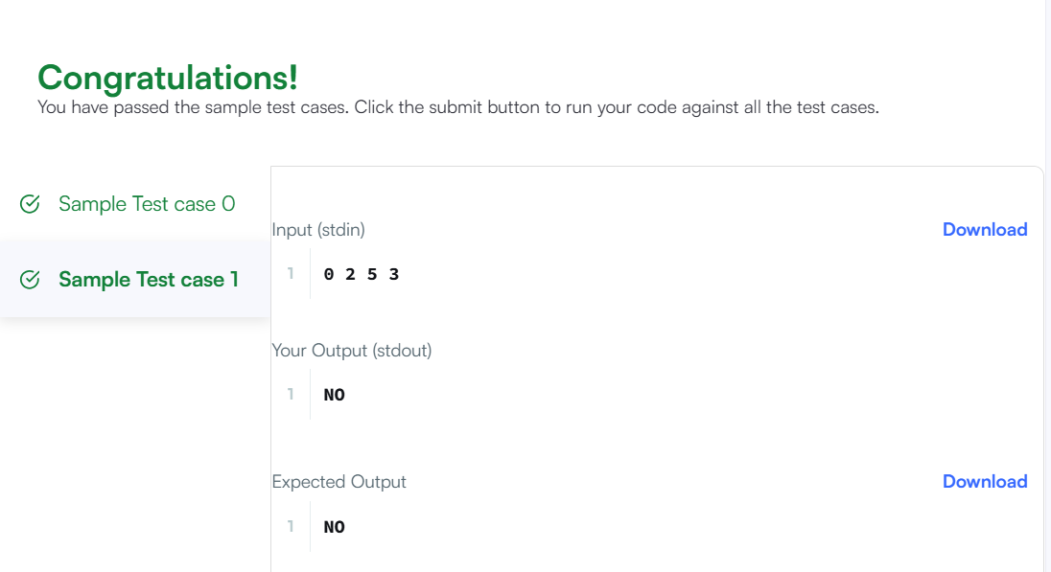Result
The program was executed successfully, and all test cases were passed on HackerRank.

